**RDS MULTI-AZ FAILOVER:**

1 Create VPC with 2 private subnets and 1 public subnet

2 Launch MySQL RDS instance in Multi-AZ deployment mode

3 Create RDS DB subnet group consisting 2 private subnets

4 Launch EC2 instance in public subnet and connect over SSH

5 Install mysql client and connect to RDS instance using RDS DNS endpoint

6 Create table and insert some records

7 From console, take a note down the AZ in which RDS Master is running

8 Reboot RDS instance -> Select Option "Reboot with Failover"

10. Wait for 10 seconds and verify that you can still connect to MySQL DB using

same DNS endpoint fromn EC2 instance

11. Verify that you can see all the records you had inserted

Wait for upto 5 minutes and verify that RDS DB instance AZ changes in the

Console.

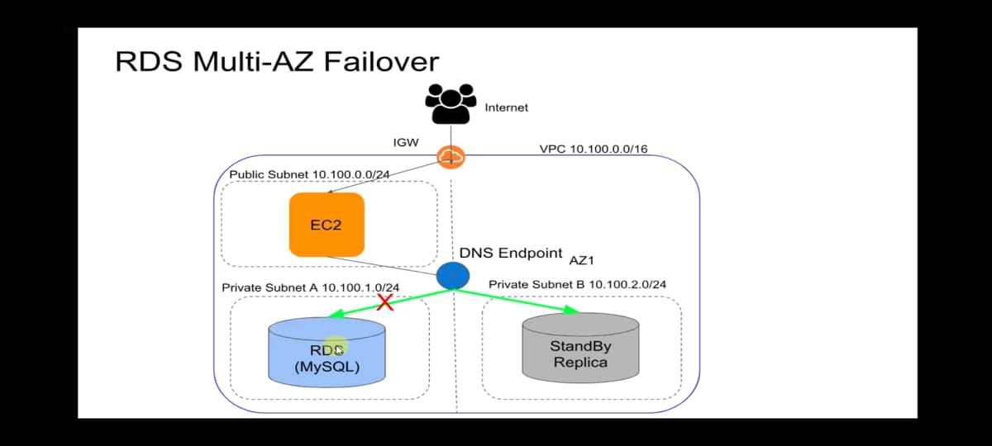

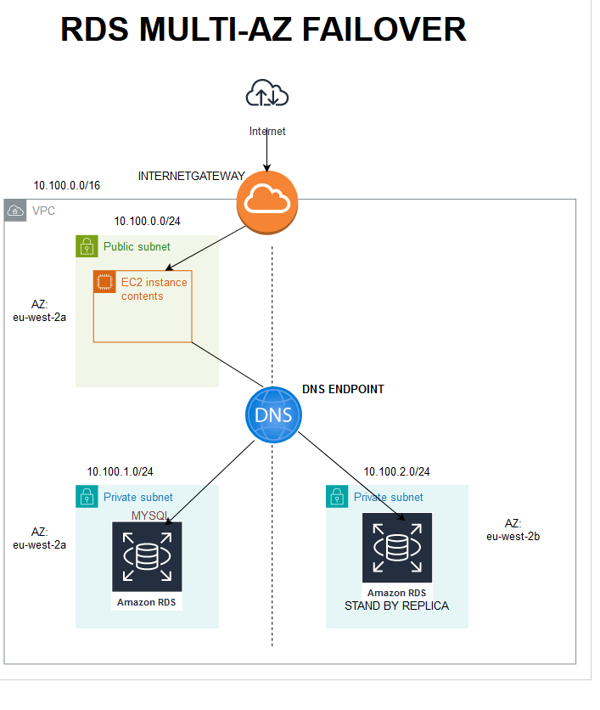

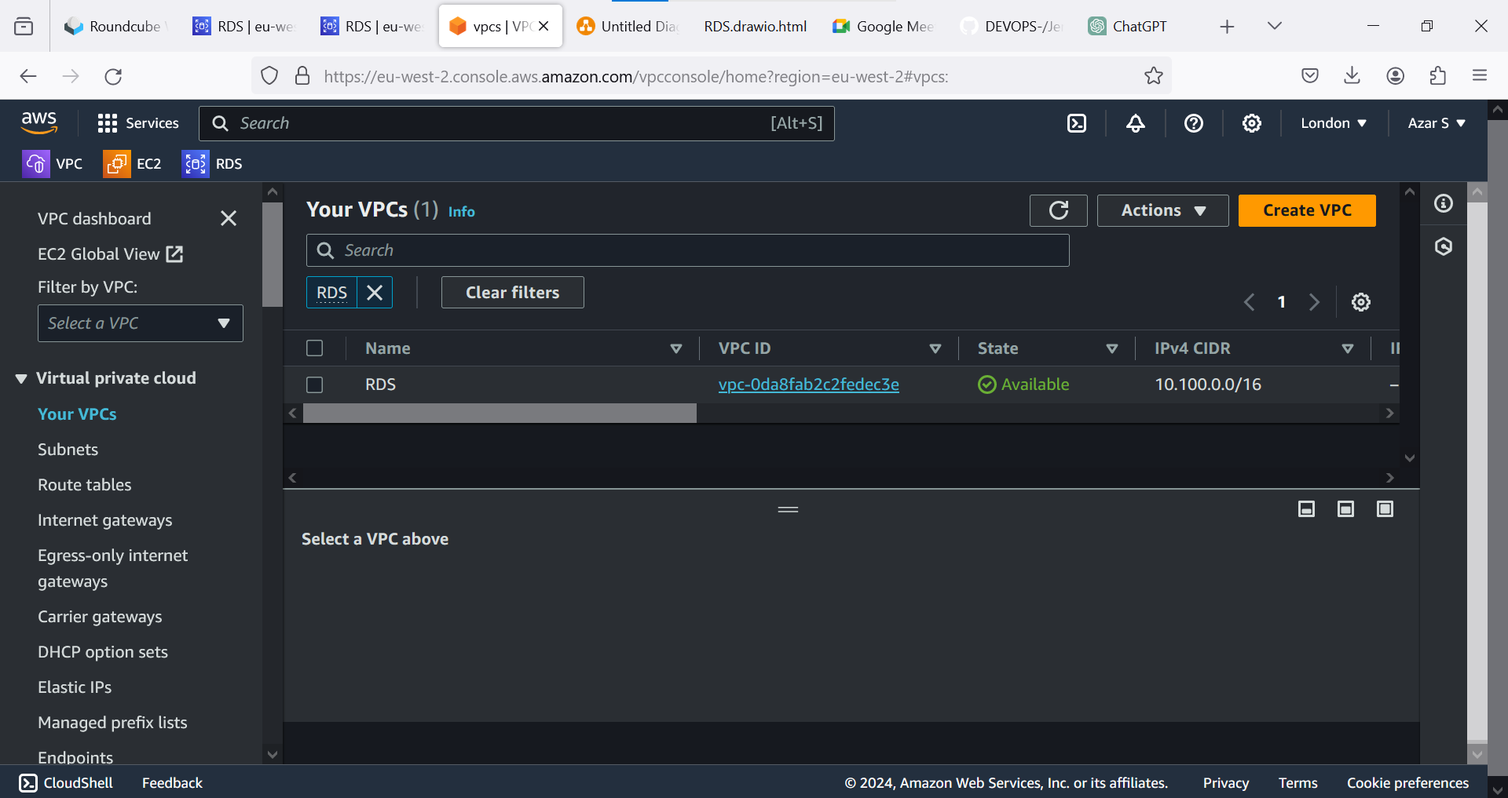 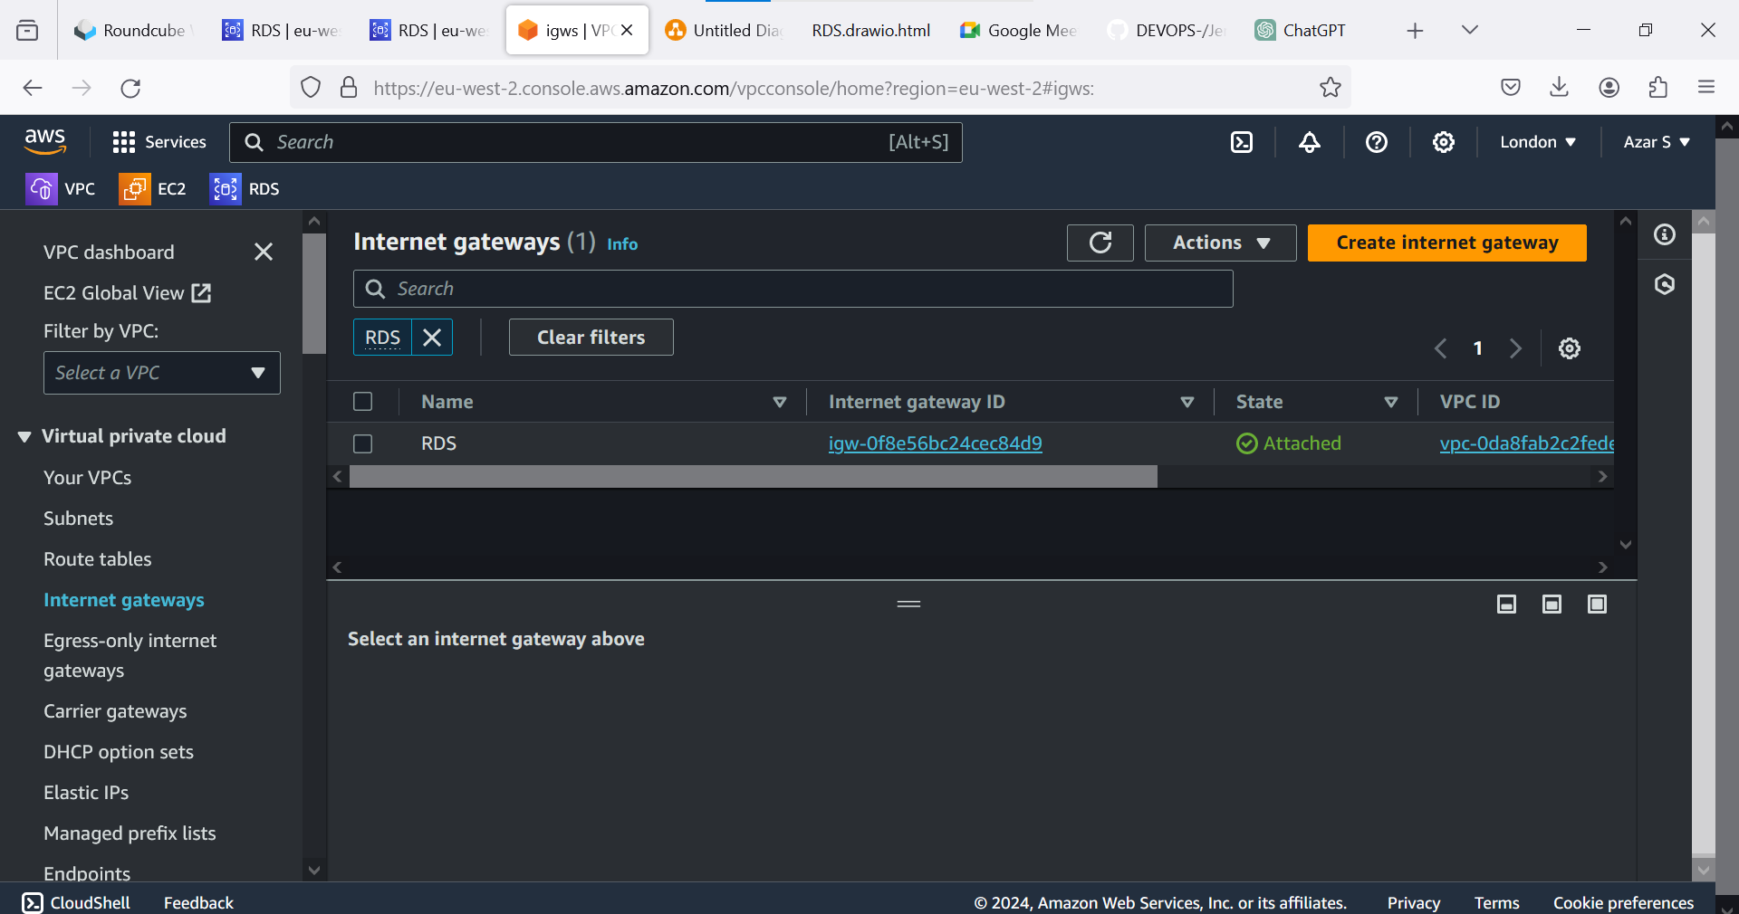 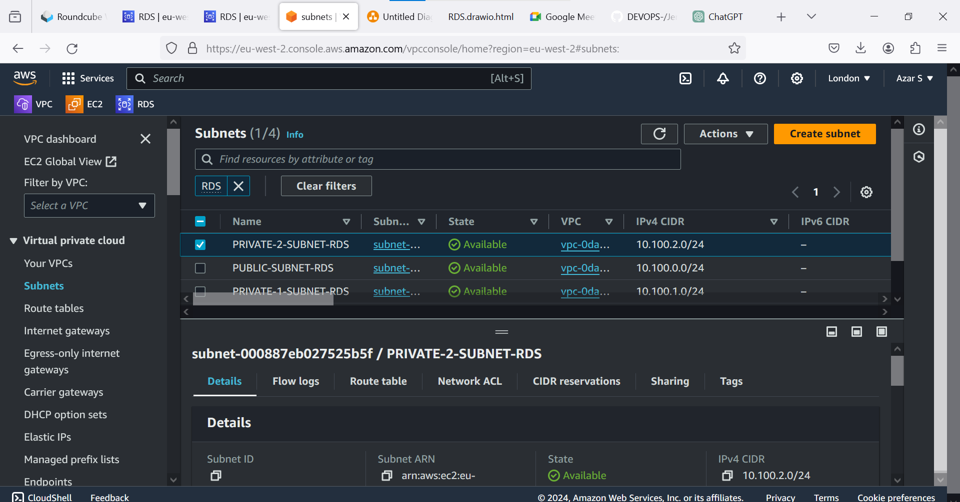 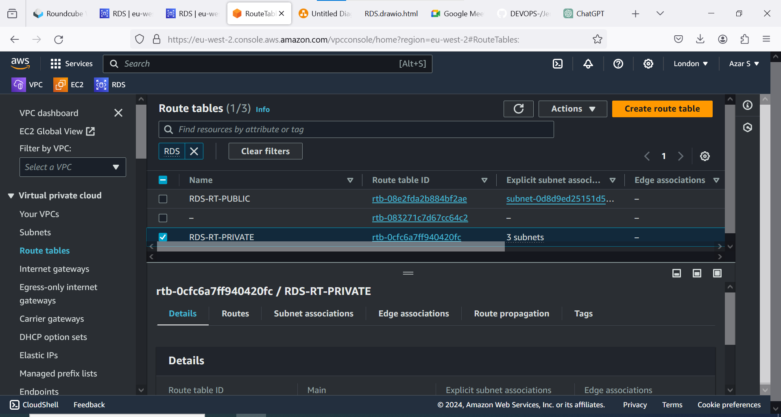 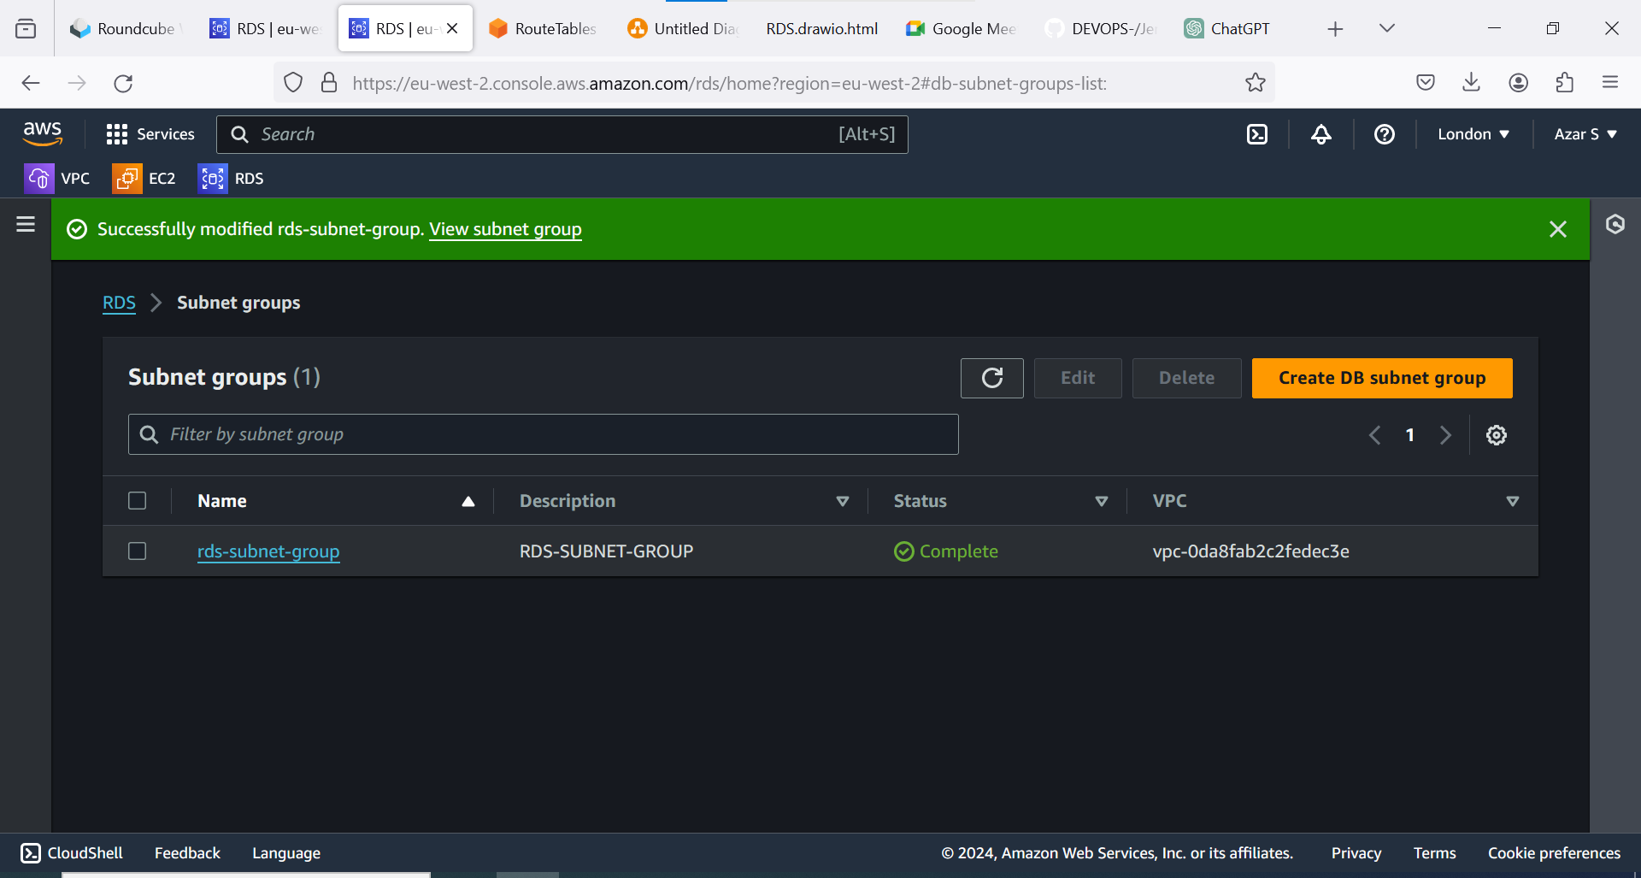 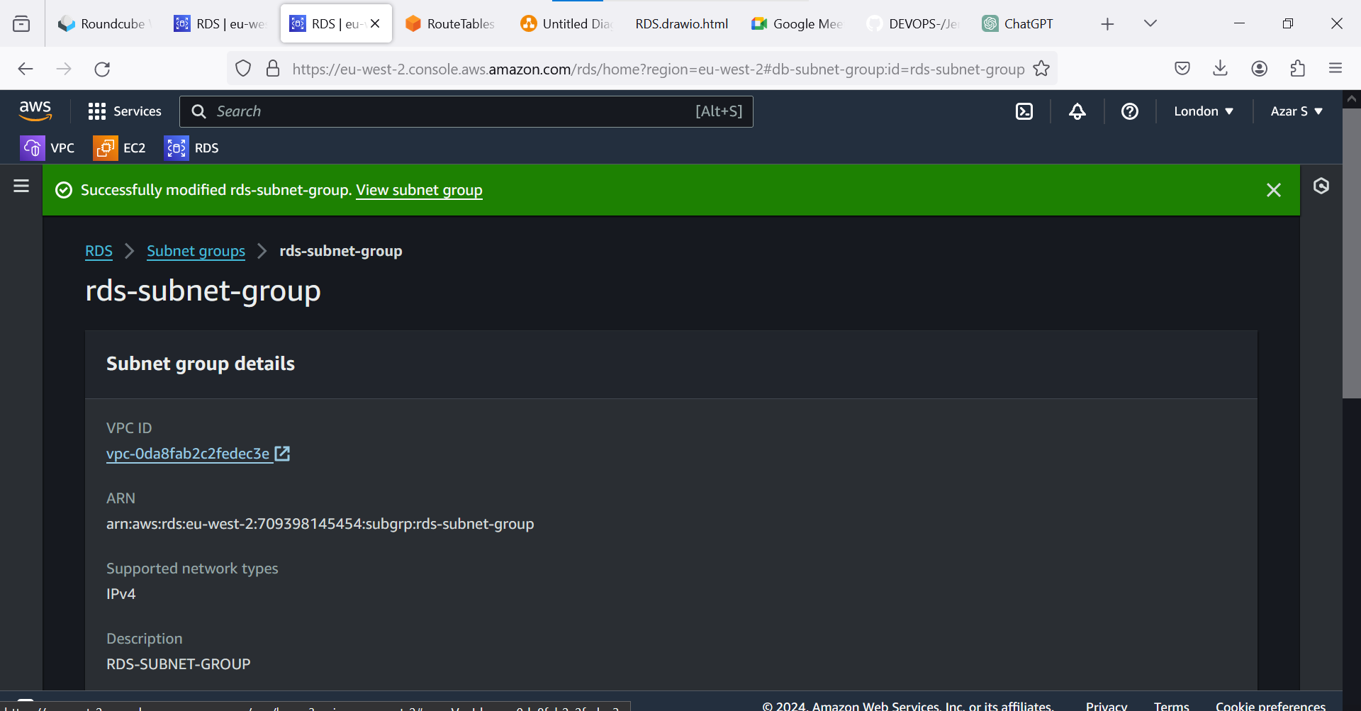 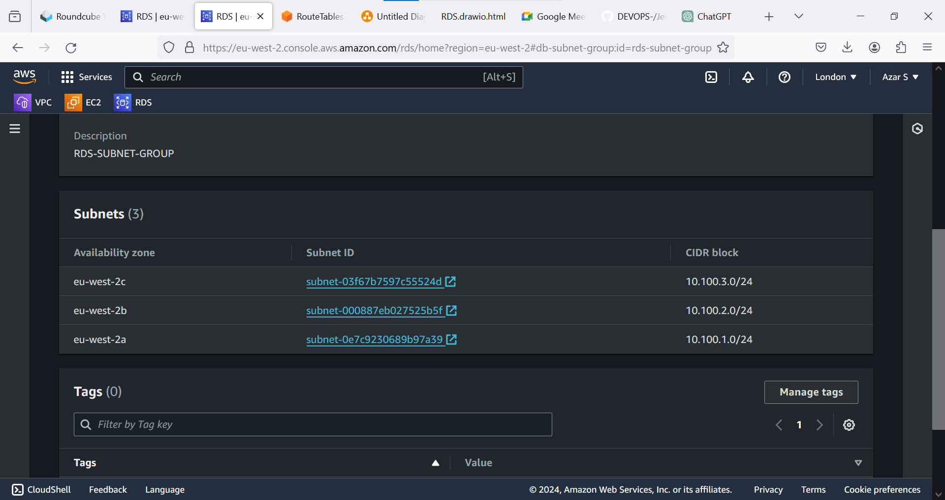 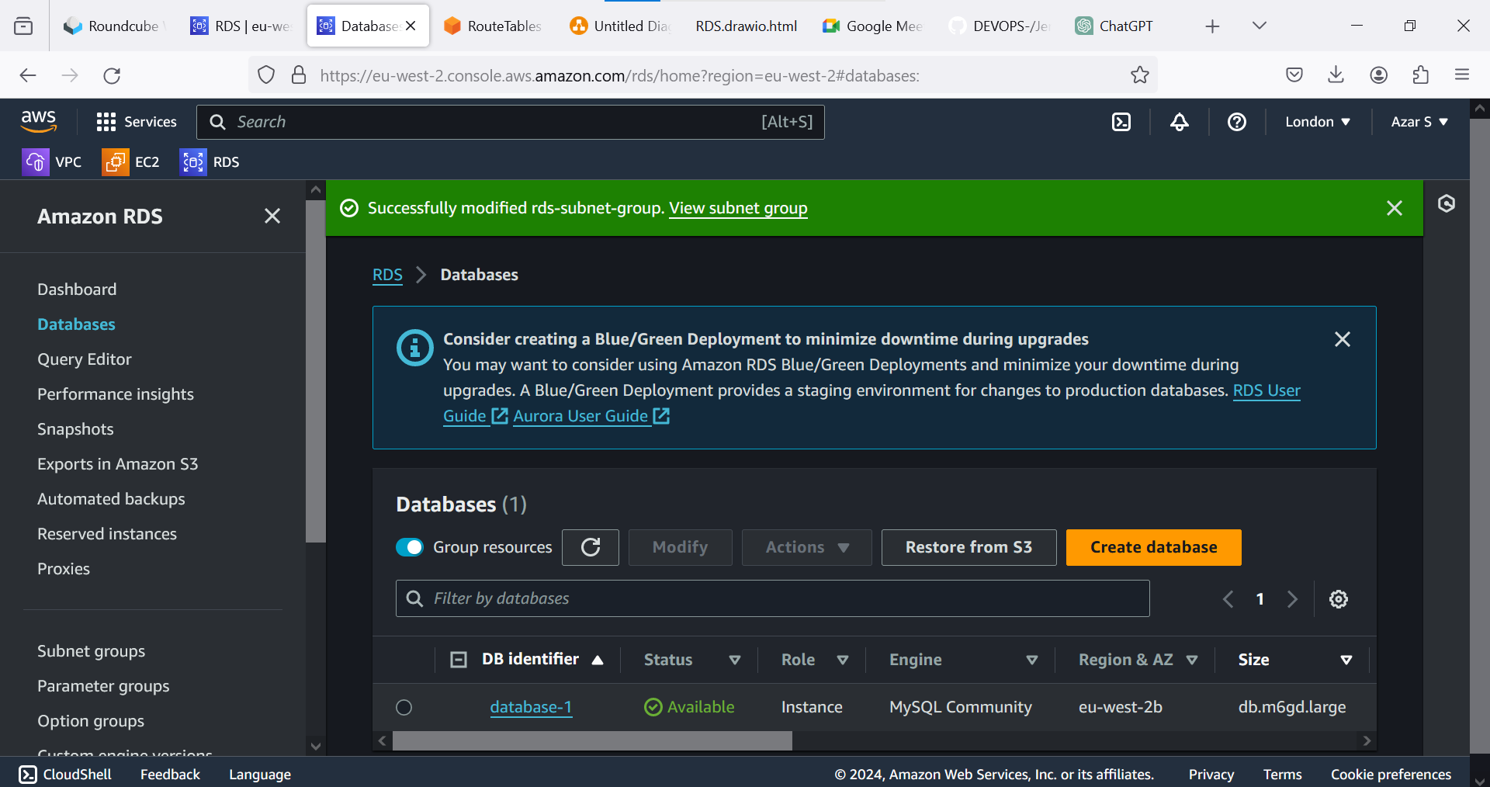 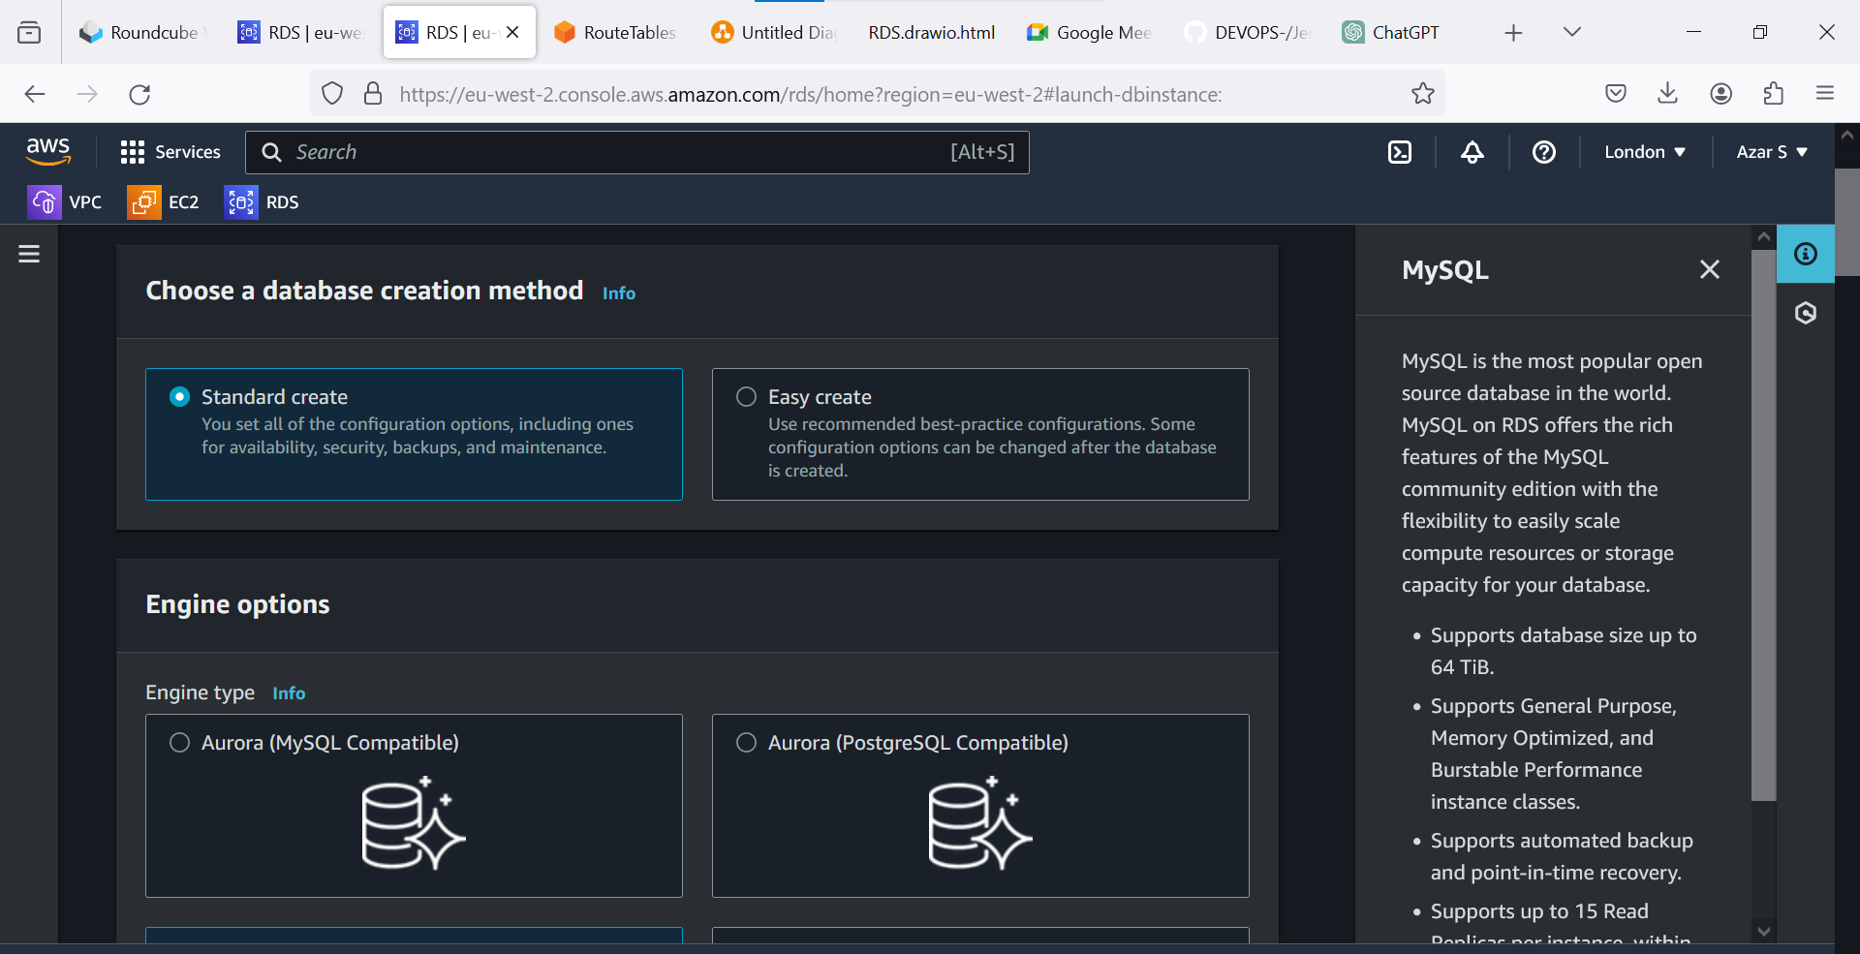 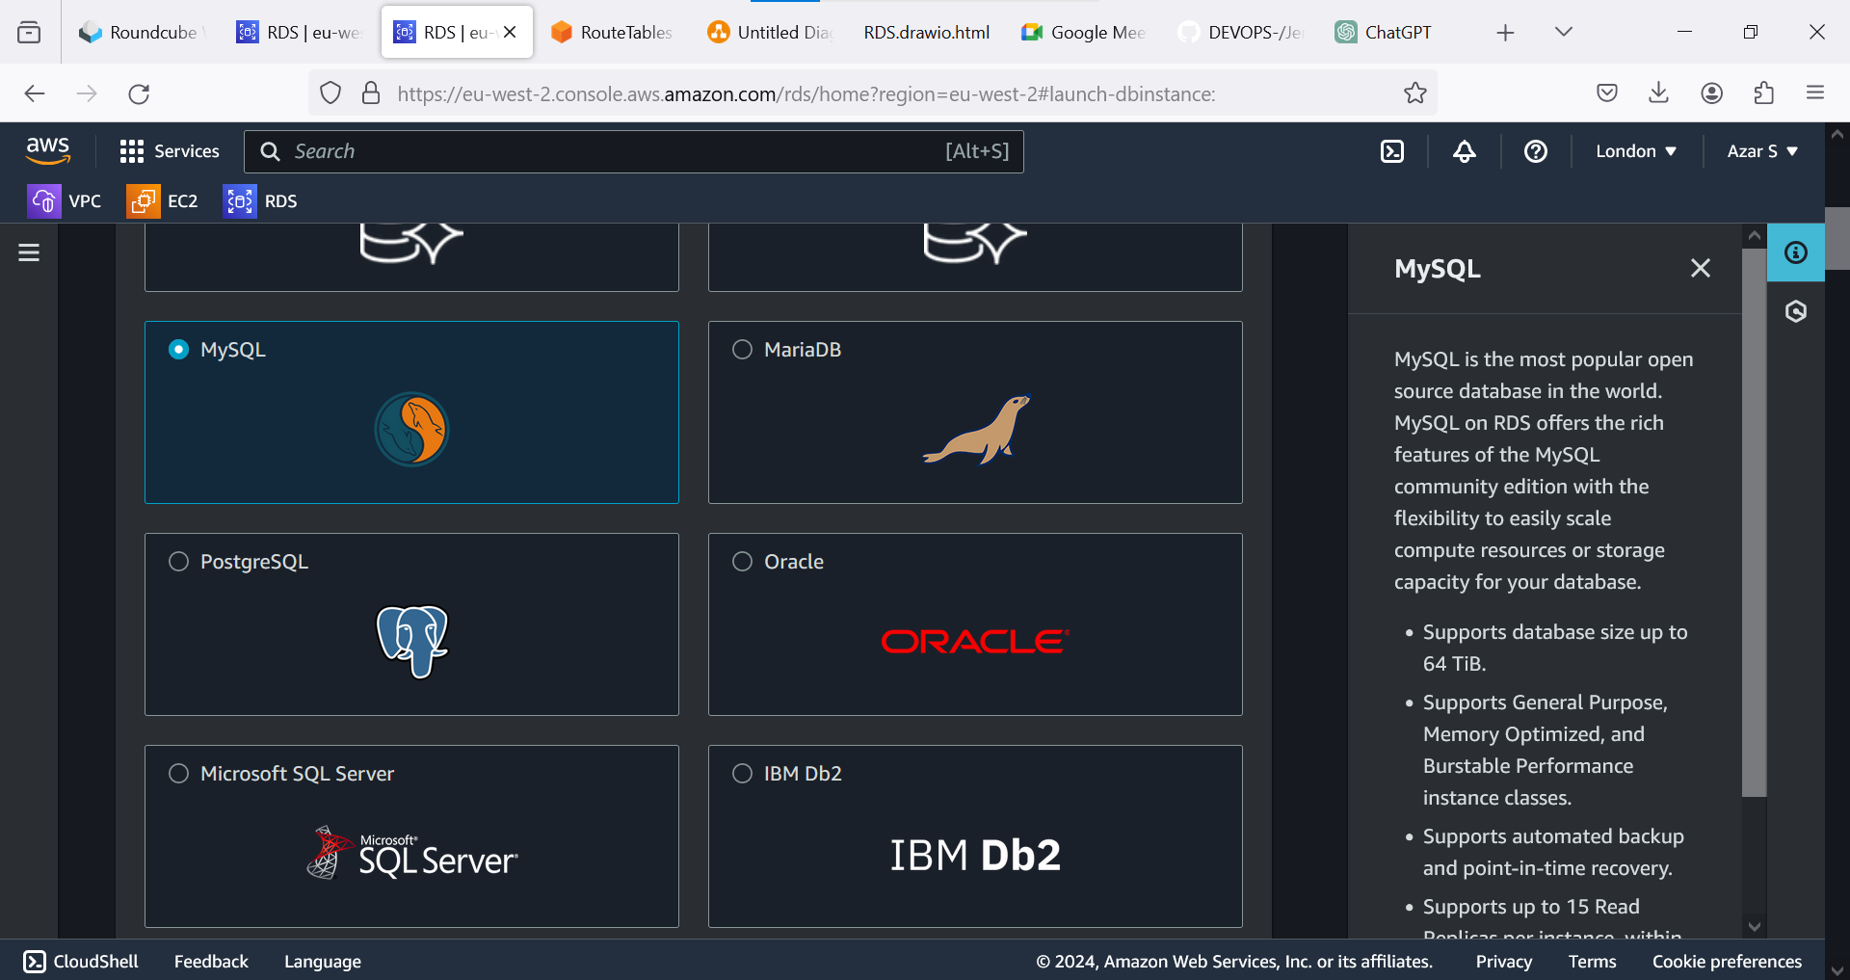 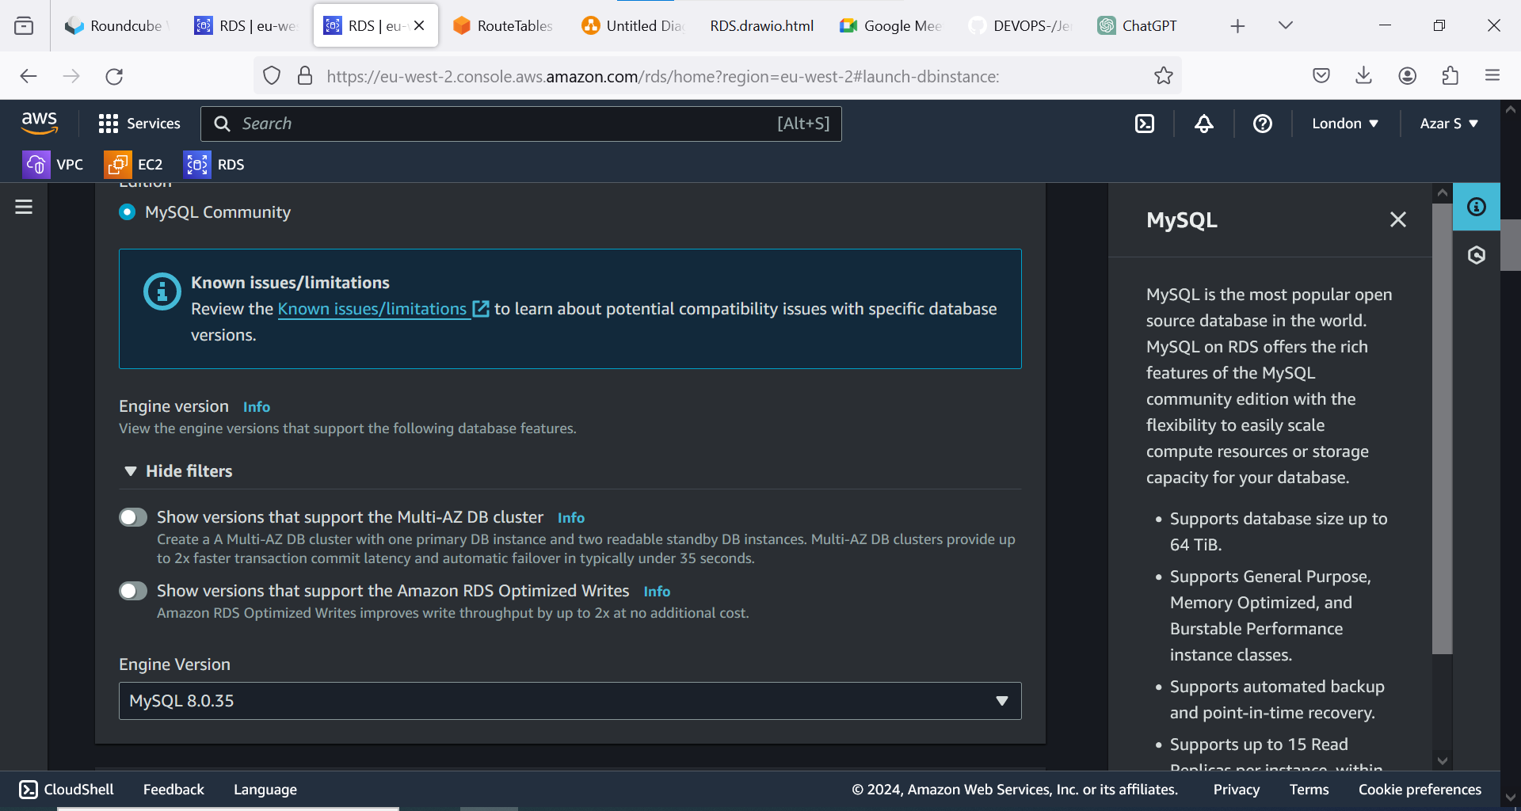 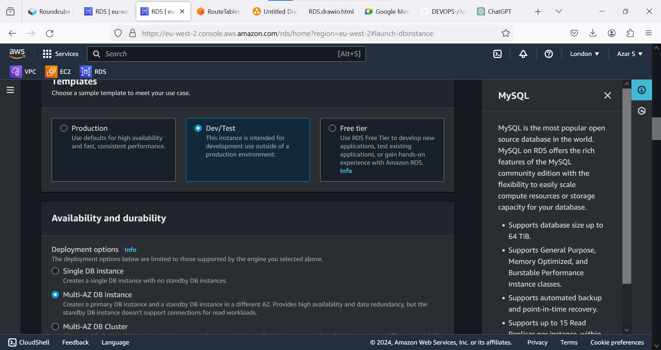 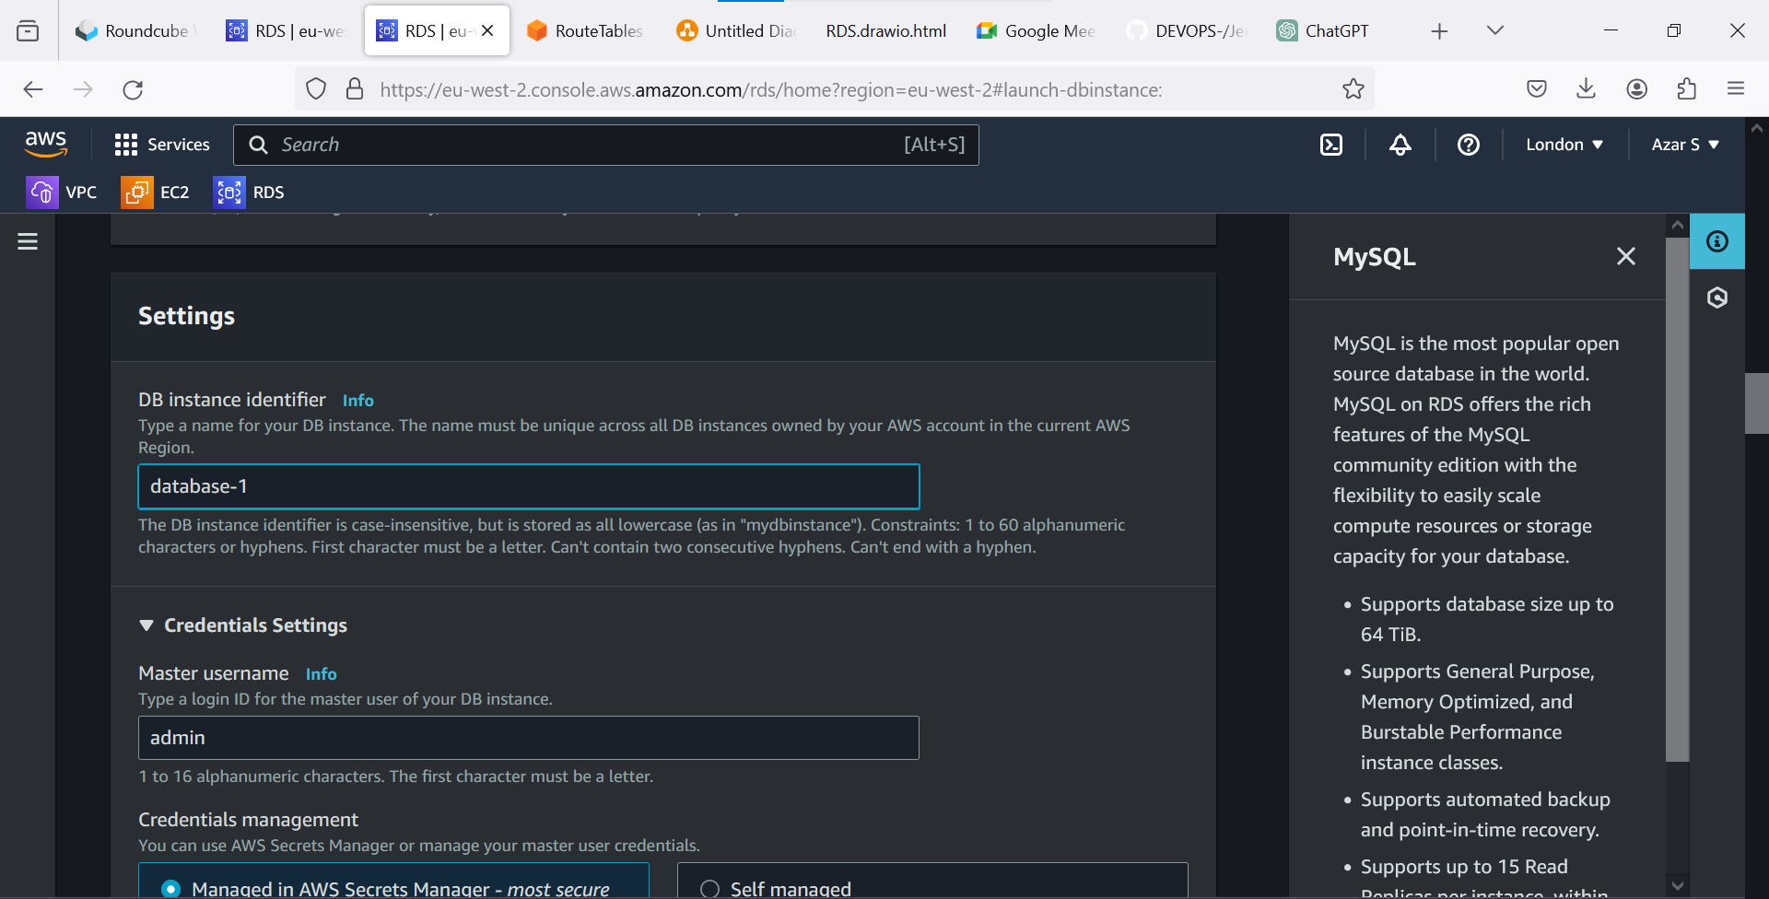 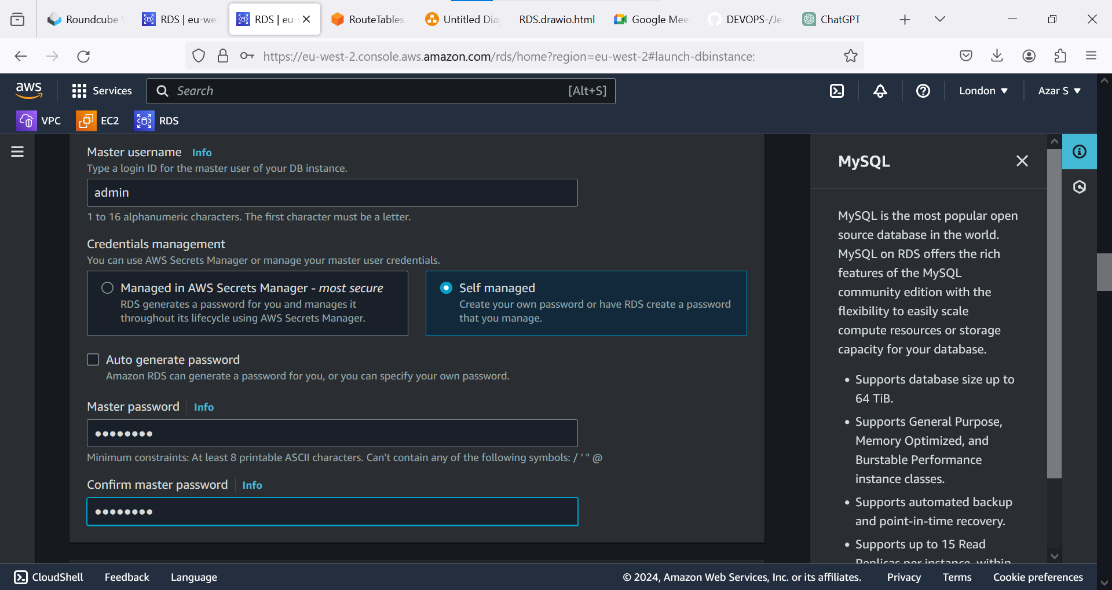 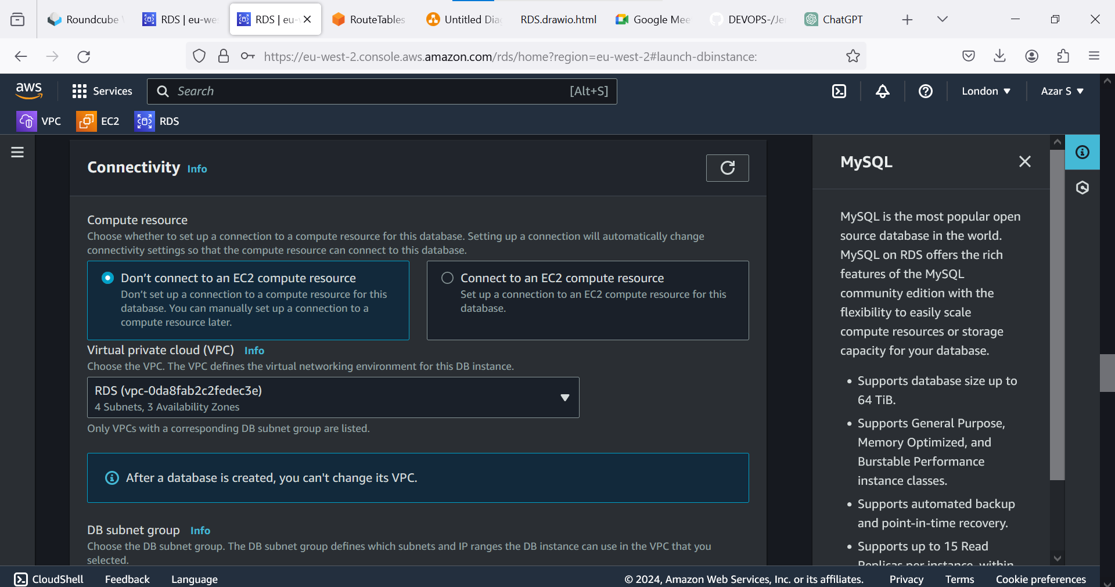 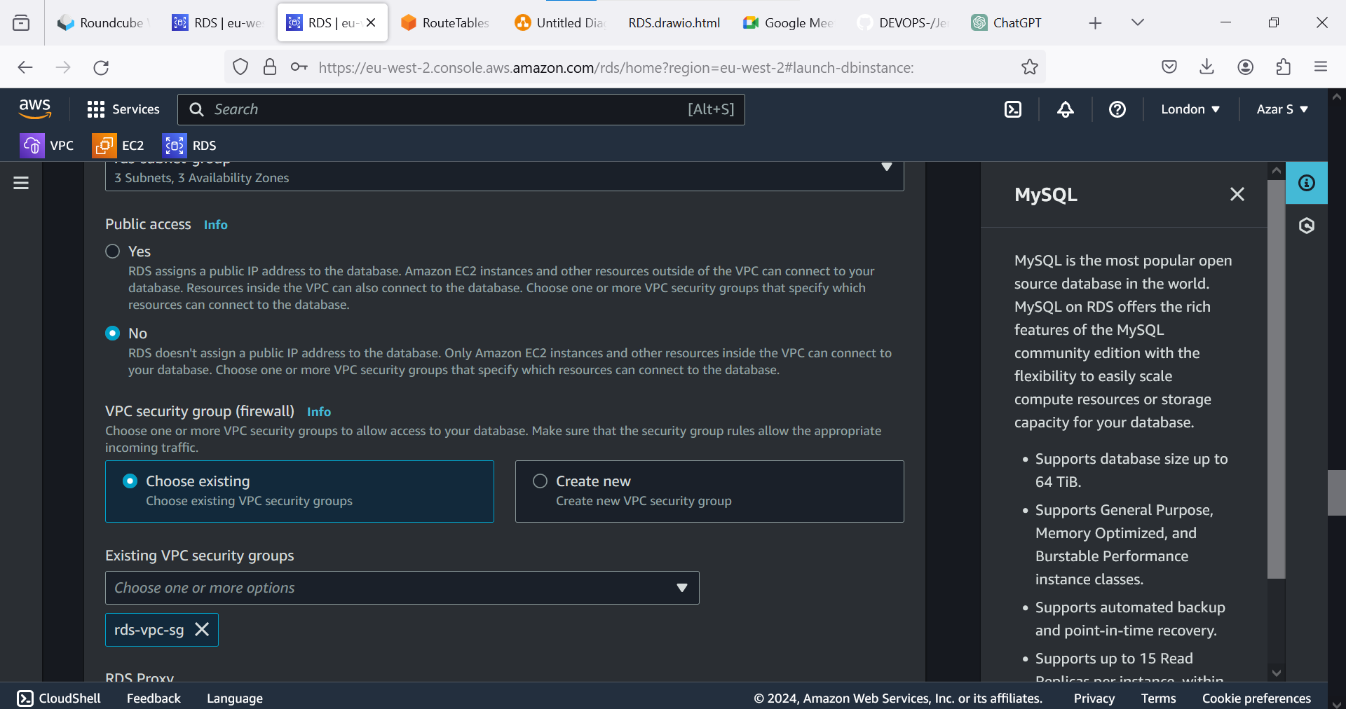 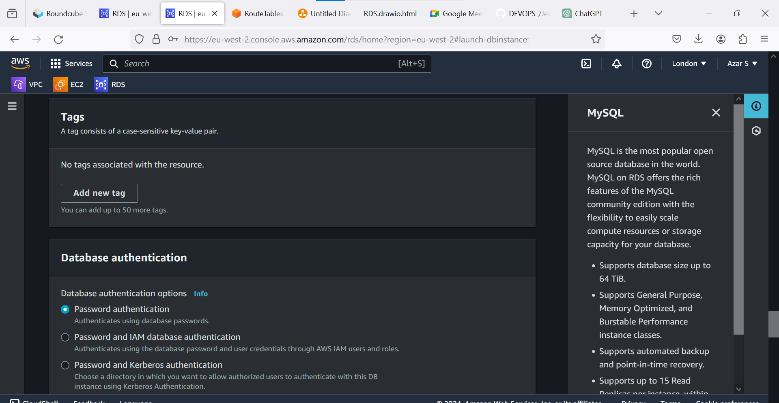 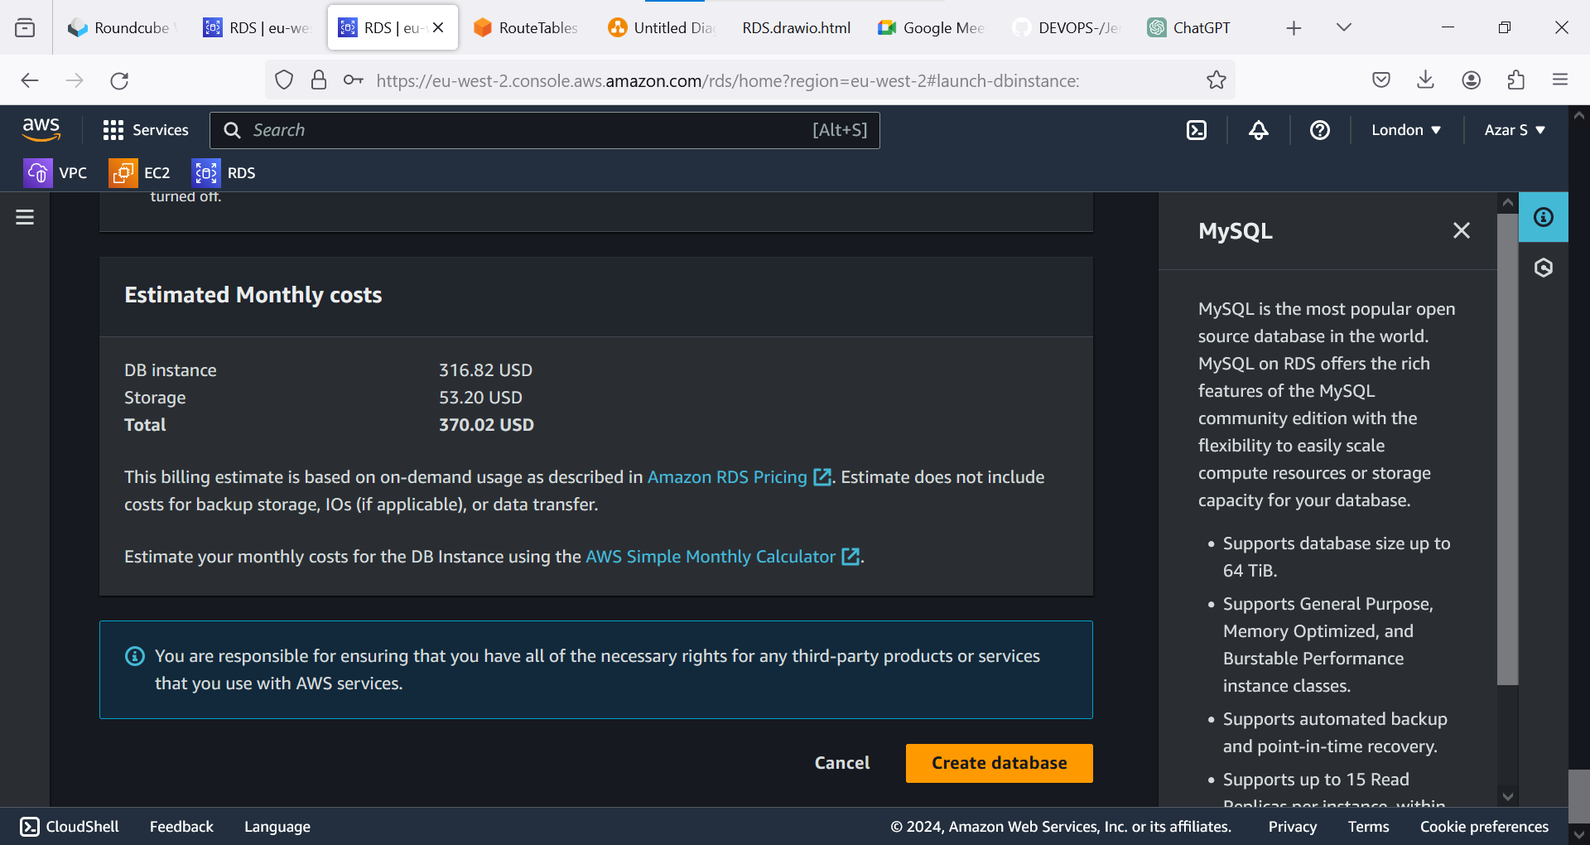 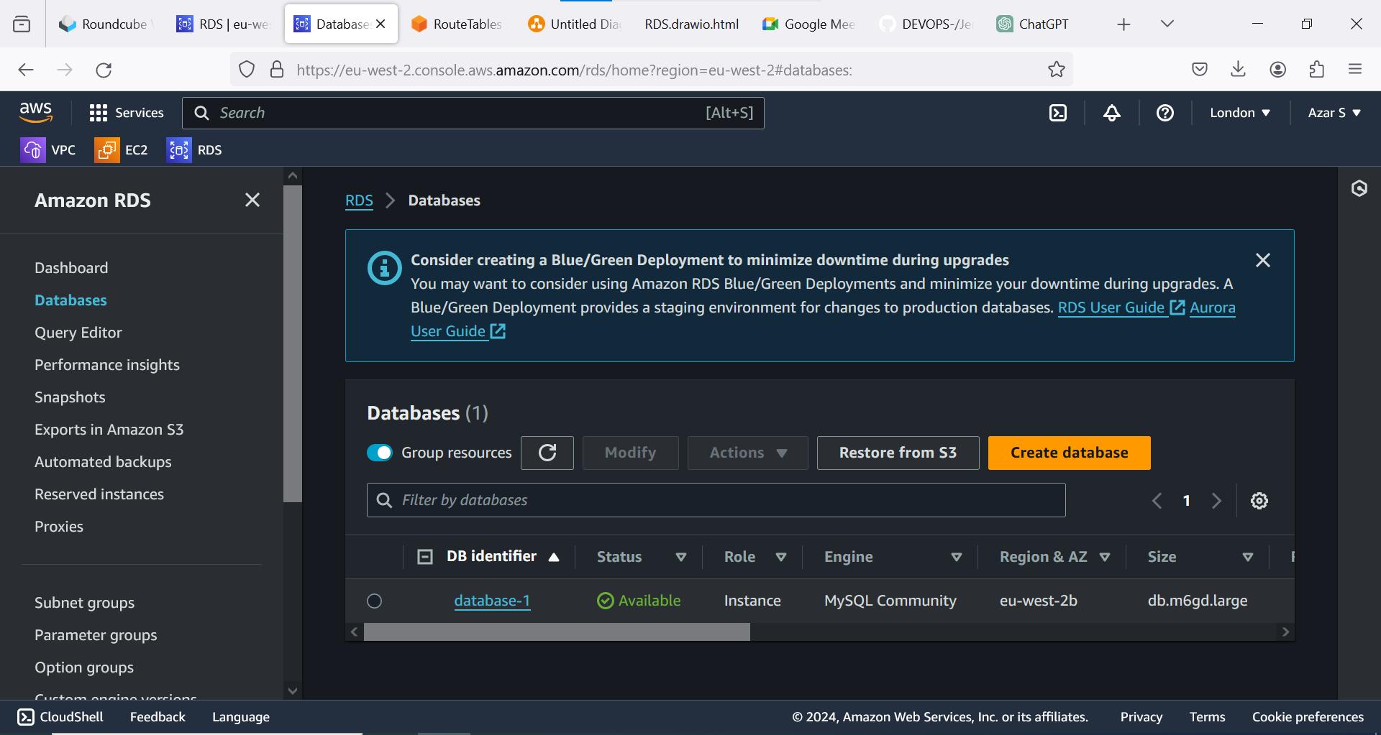 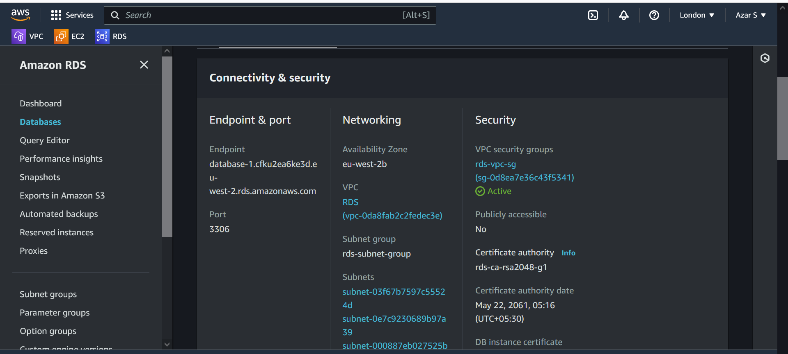 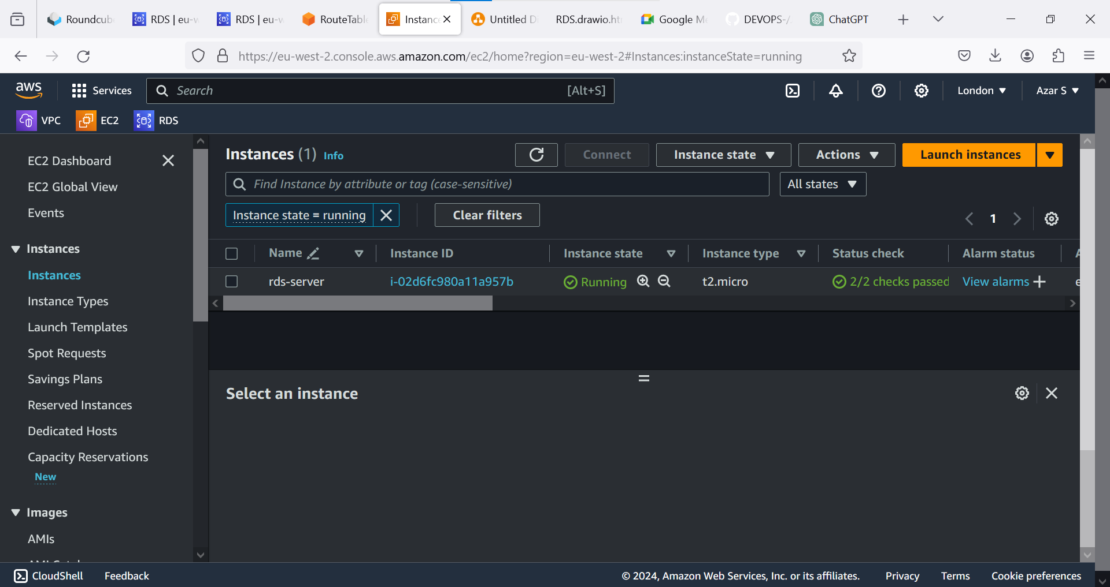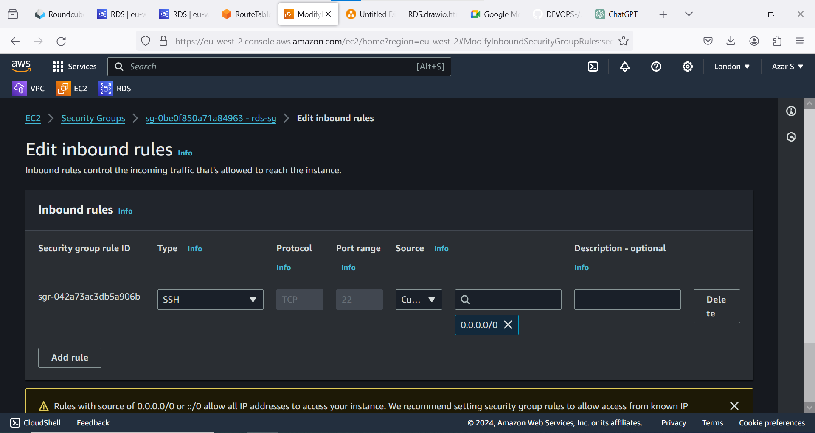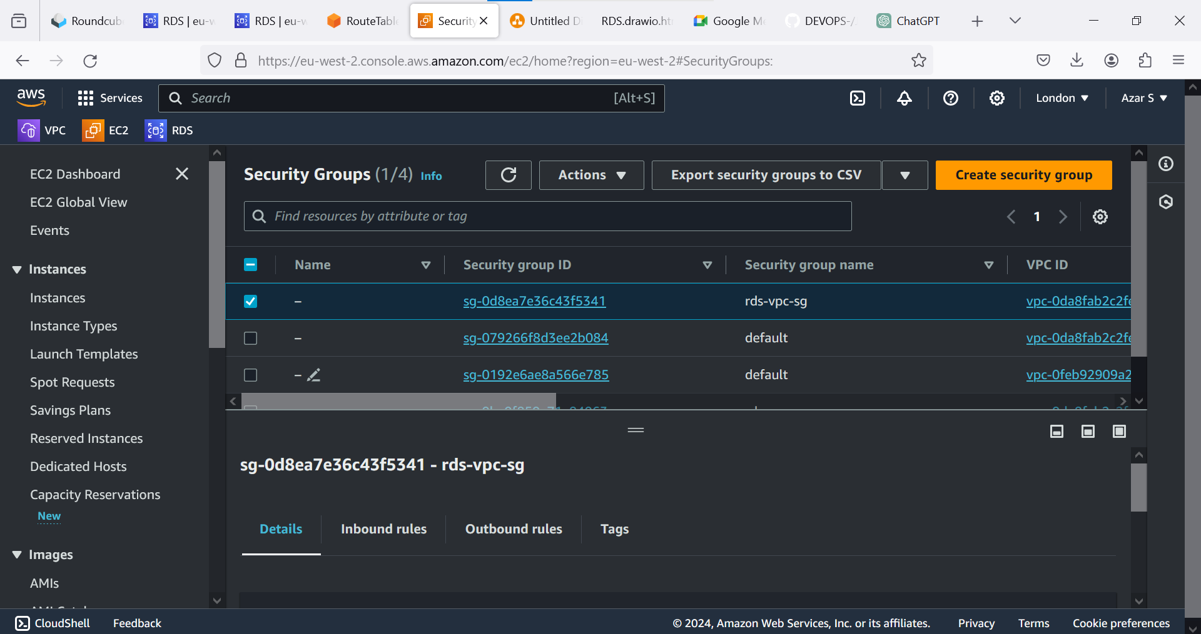

**IN RDS SECURITY GROUP:**

**We have to enter vpc ip or ec2 ip in rds security group.**

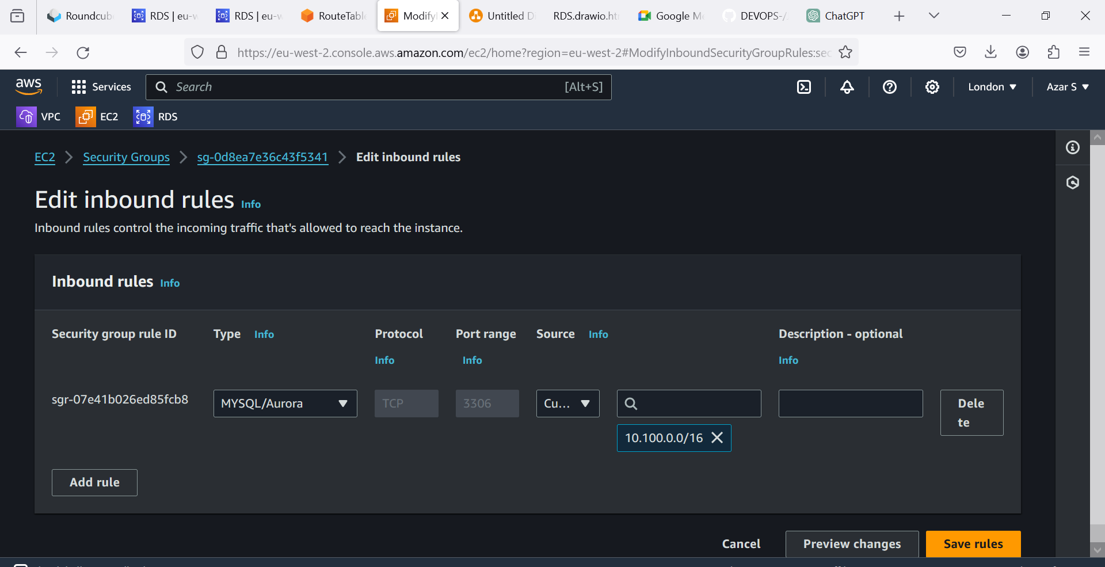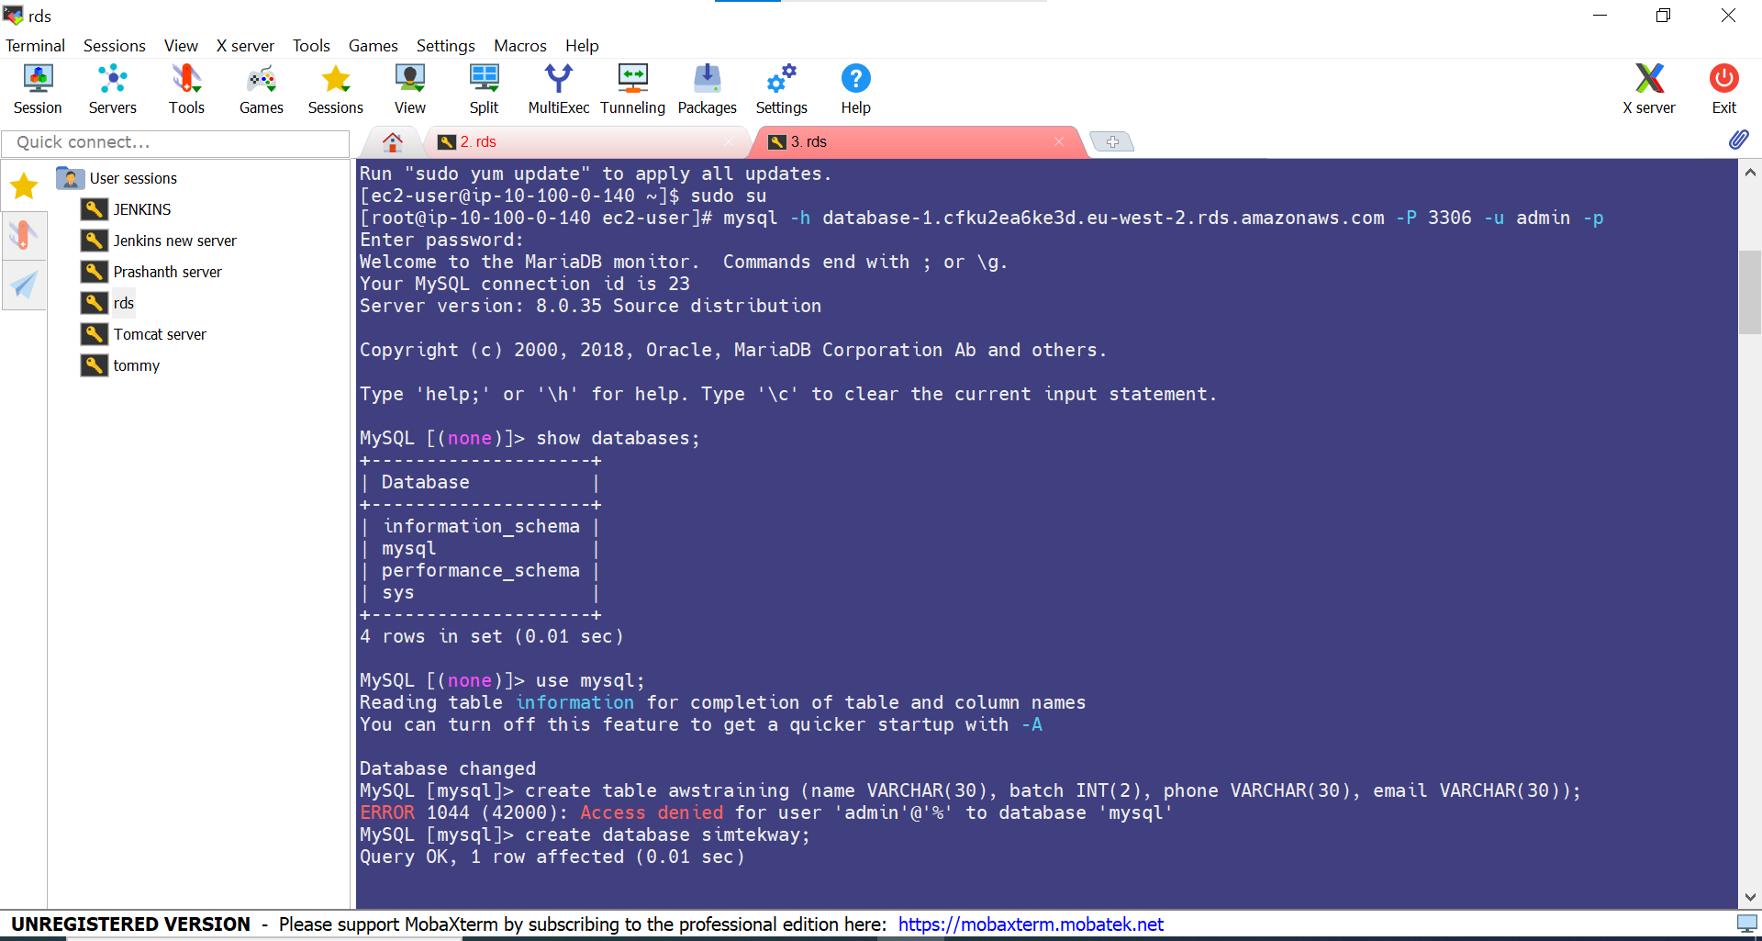 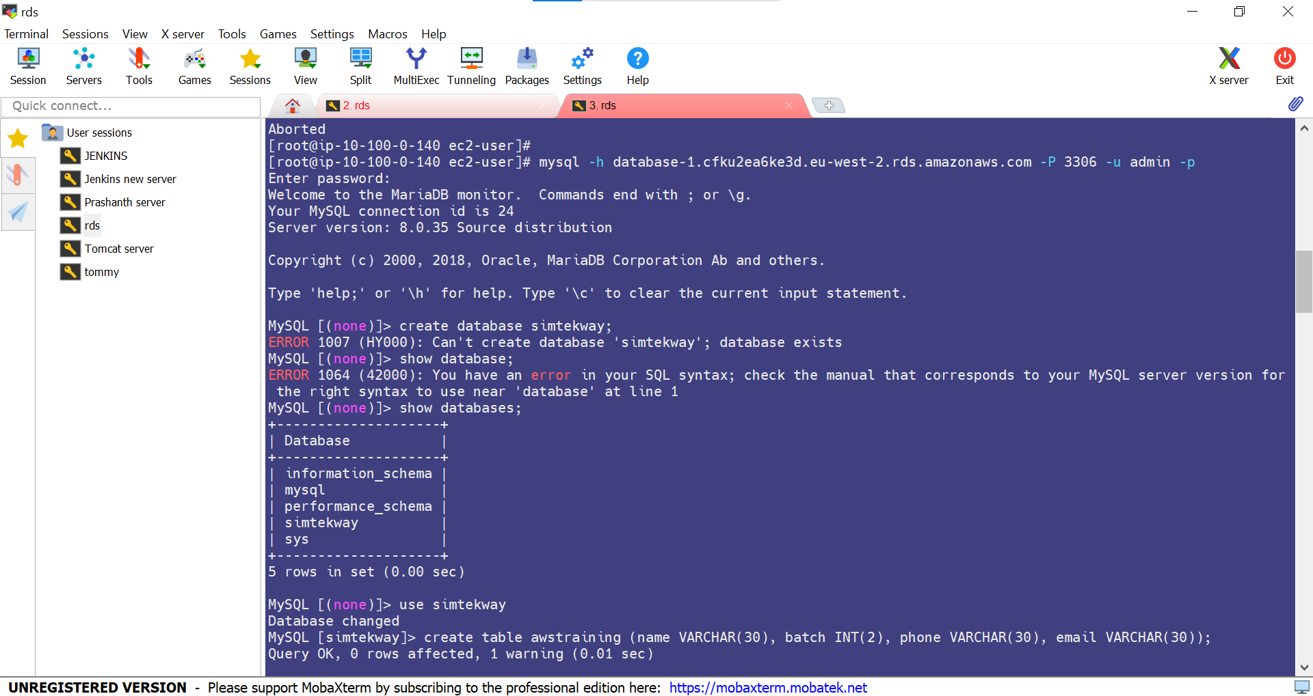 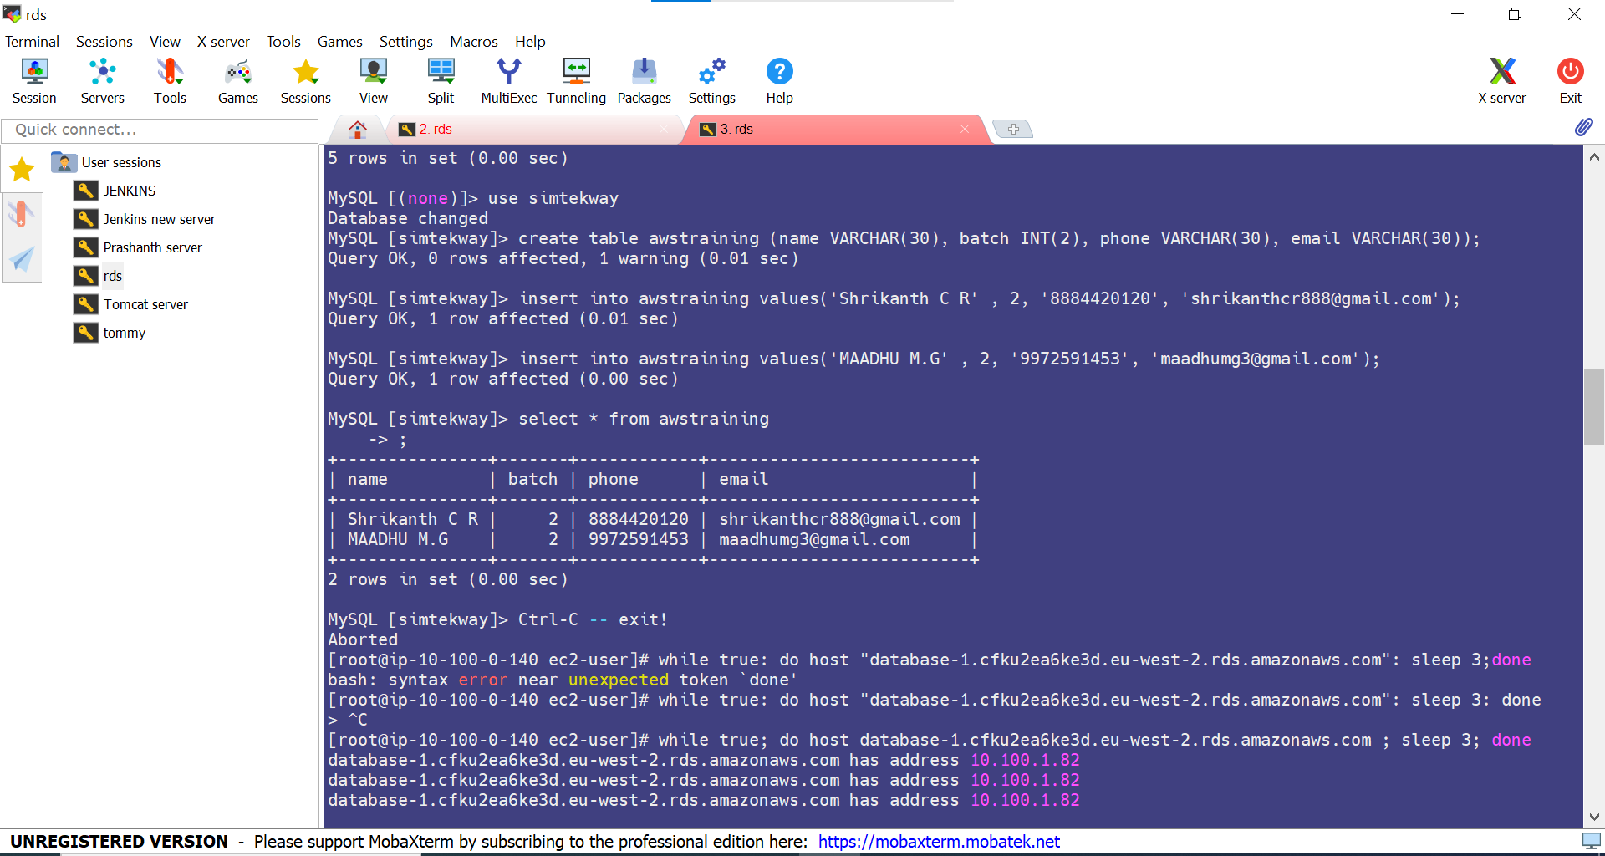 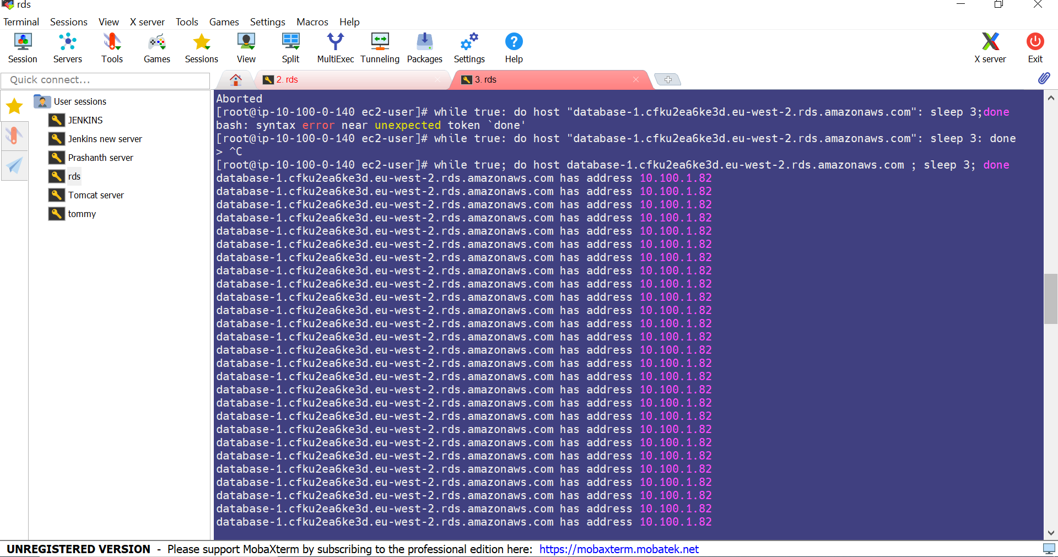

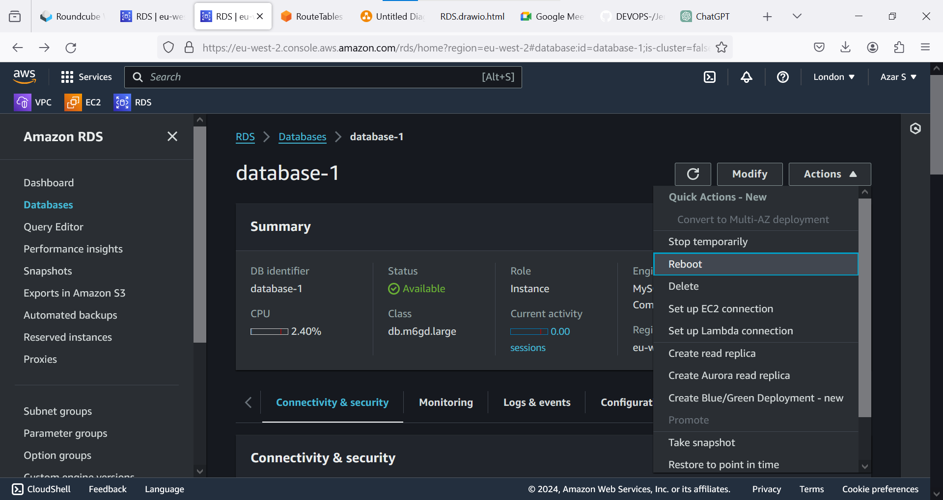 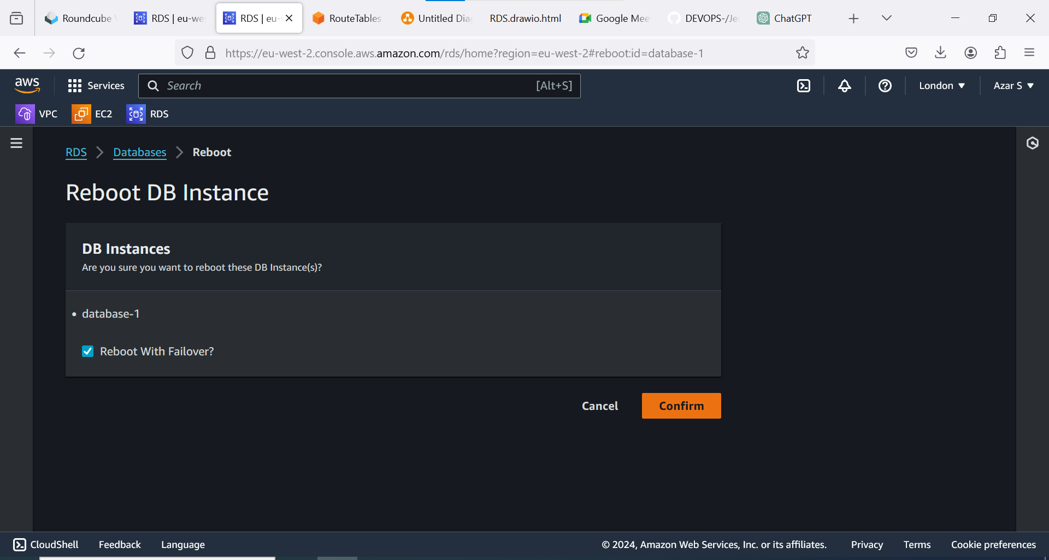 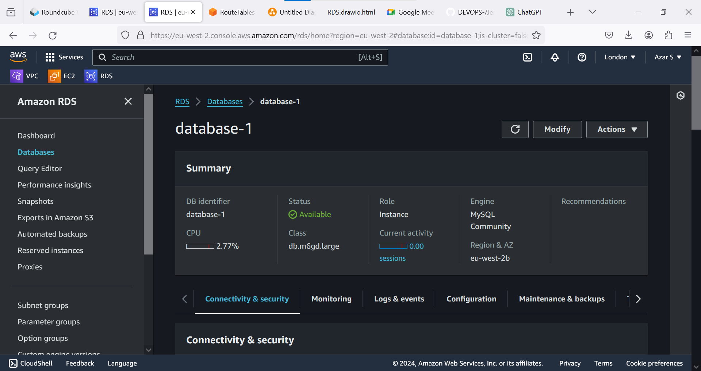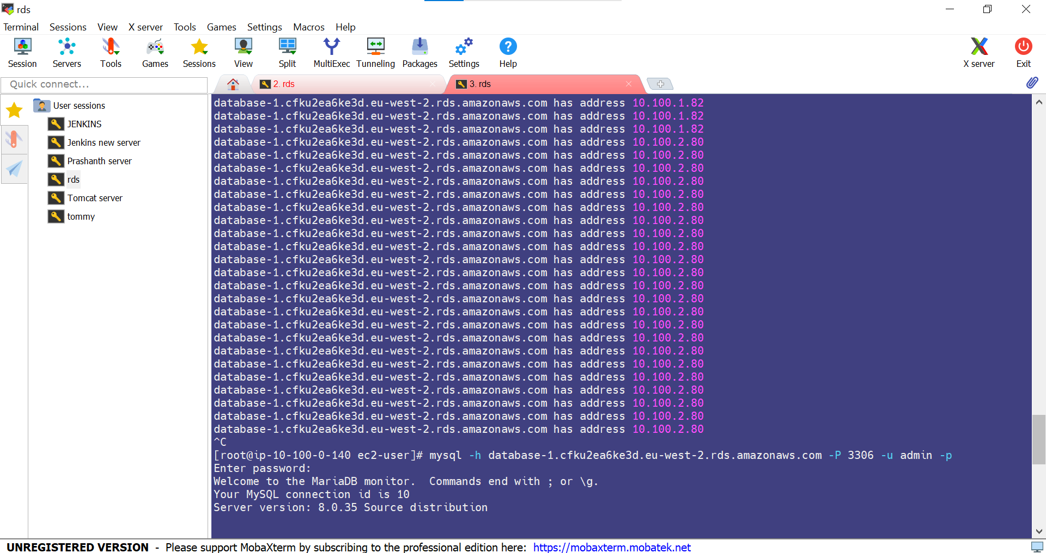 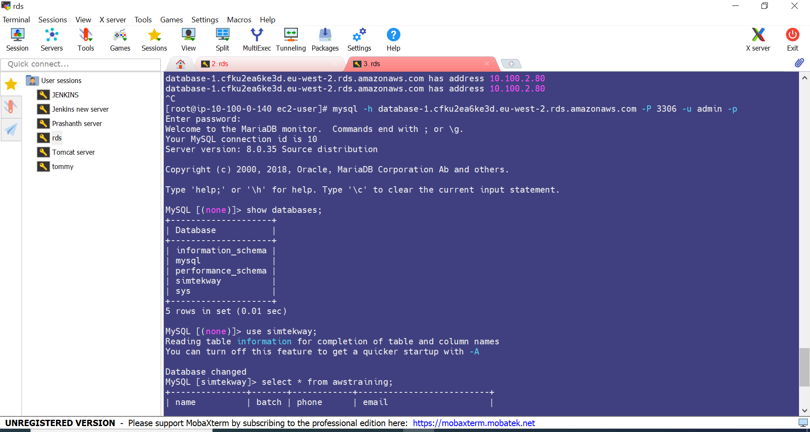 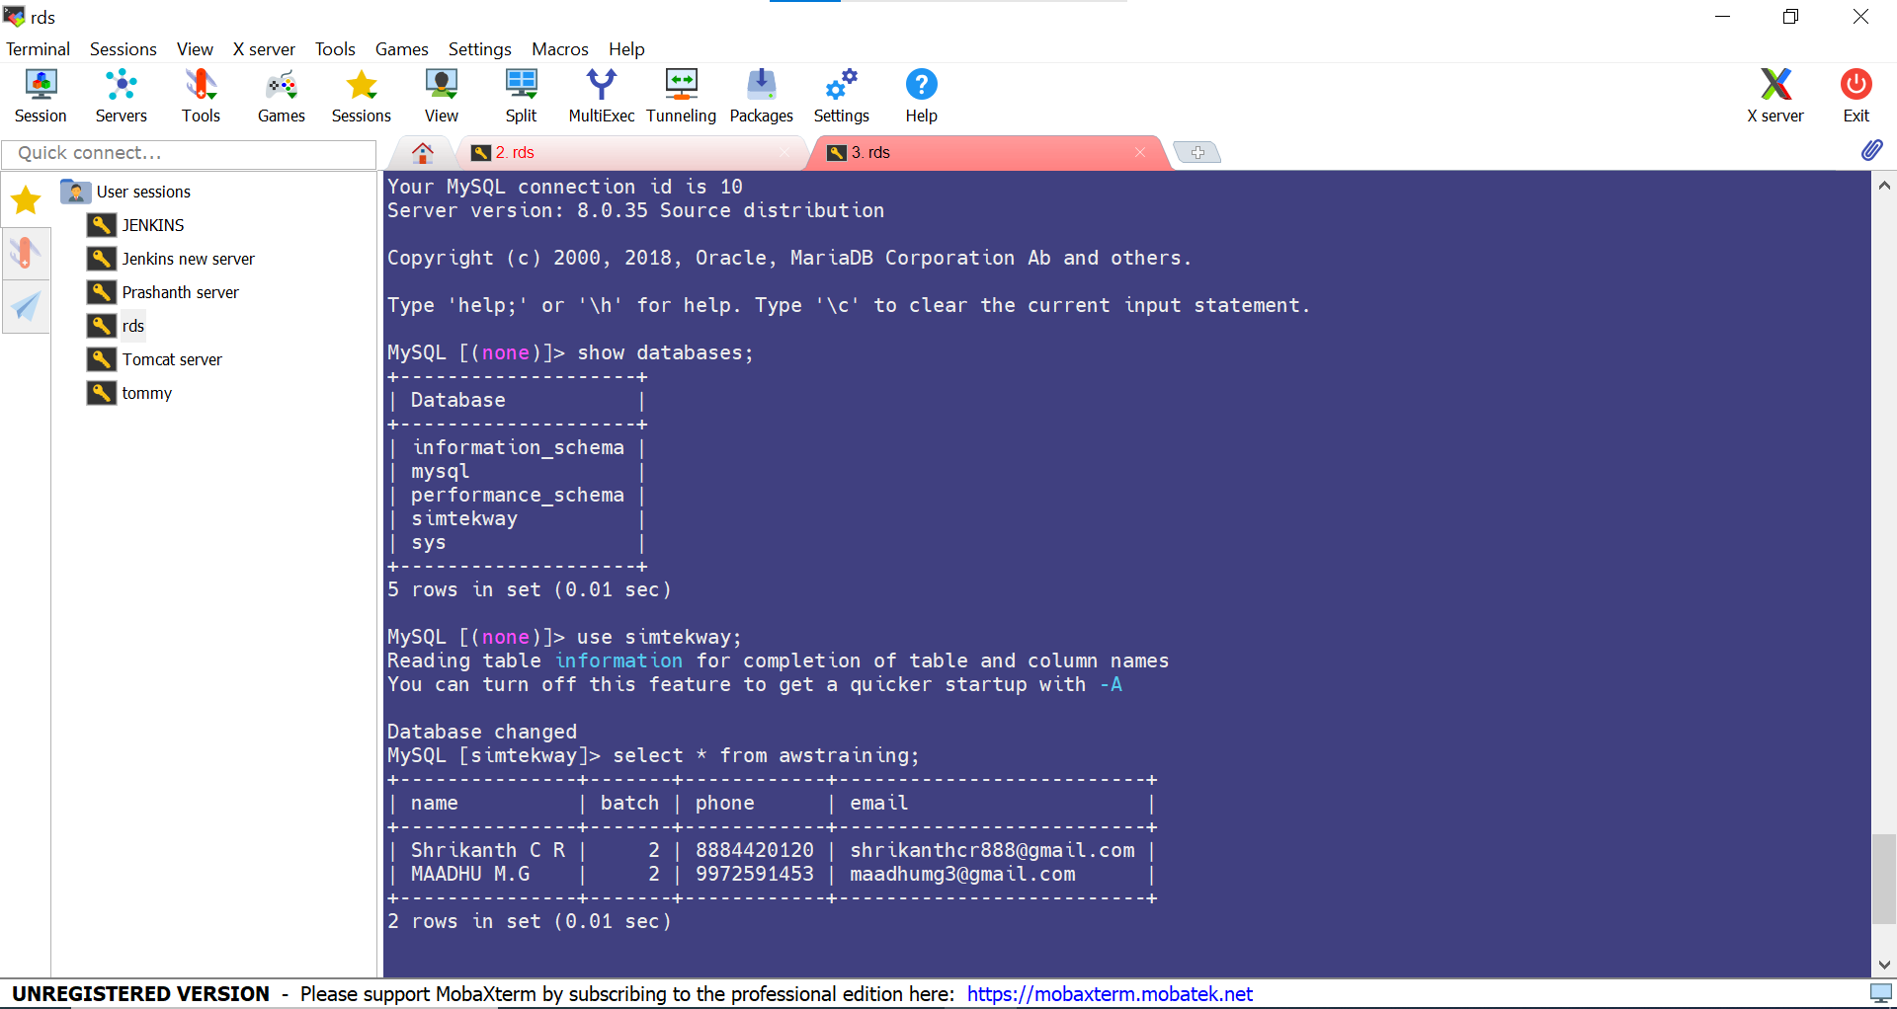

**SQL COMMANDS:**

**Connect rds with ec2 :**

mysql -h rds.cfku2ea6ke3d.eu-west-2.rds.amazonaws.com -P 3306 -u admin -p admin123

**Create Database:**

create database simtekway:

show databases;

use simtekway;

**Create Table:**

create table awstraining (name VARCHAR(30), batch INT(2), phone VARCHAR(30), email VARCHAR(30));

show tables;

insert into awstraining values('Shrikanth C R' , 2, '8884420120', 'shrikanthcr888@gmail.com');

insert into awstraining values('MAADHU M.G' , 2, '9972591453', 'maadhumg3@gmail.com');

select * from awstraining;

By using below command we will the see the output, when ever failure happens it will shift to another availability zone.

while true; do host database-1.cfku2ea6ke3d.eu-west-2.rds.amazonaws.com ; sleep 3; done

